**Ideation Phase**

**Brainstorm & Idea Prioritization Template**

|  |  |
| --- | --- |
| Date | 01 November 2022 |
| Team ID | PNT2022TMID22889 |
| Project name | SmartFarmer - IoT Enabled Smart Farming Application |
| Maximum marks | 4 Marks |

**Step 1: Team Gathering, Collaboration and Select the Problem Statement**

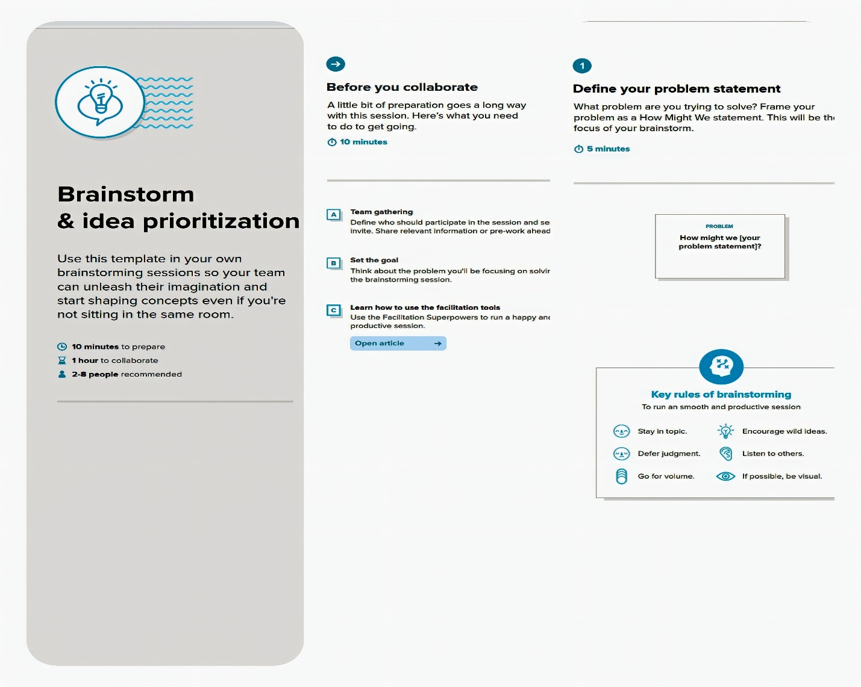

**Step 2: Brainstorm, Idea Listing and Grouping**

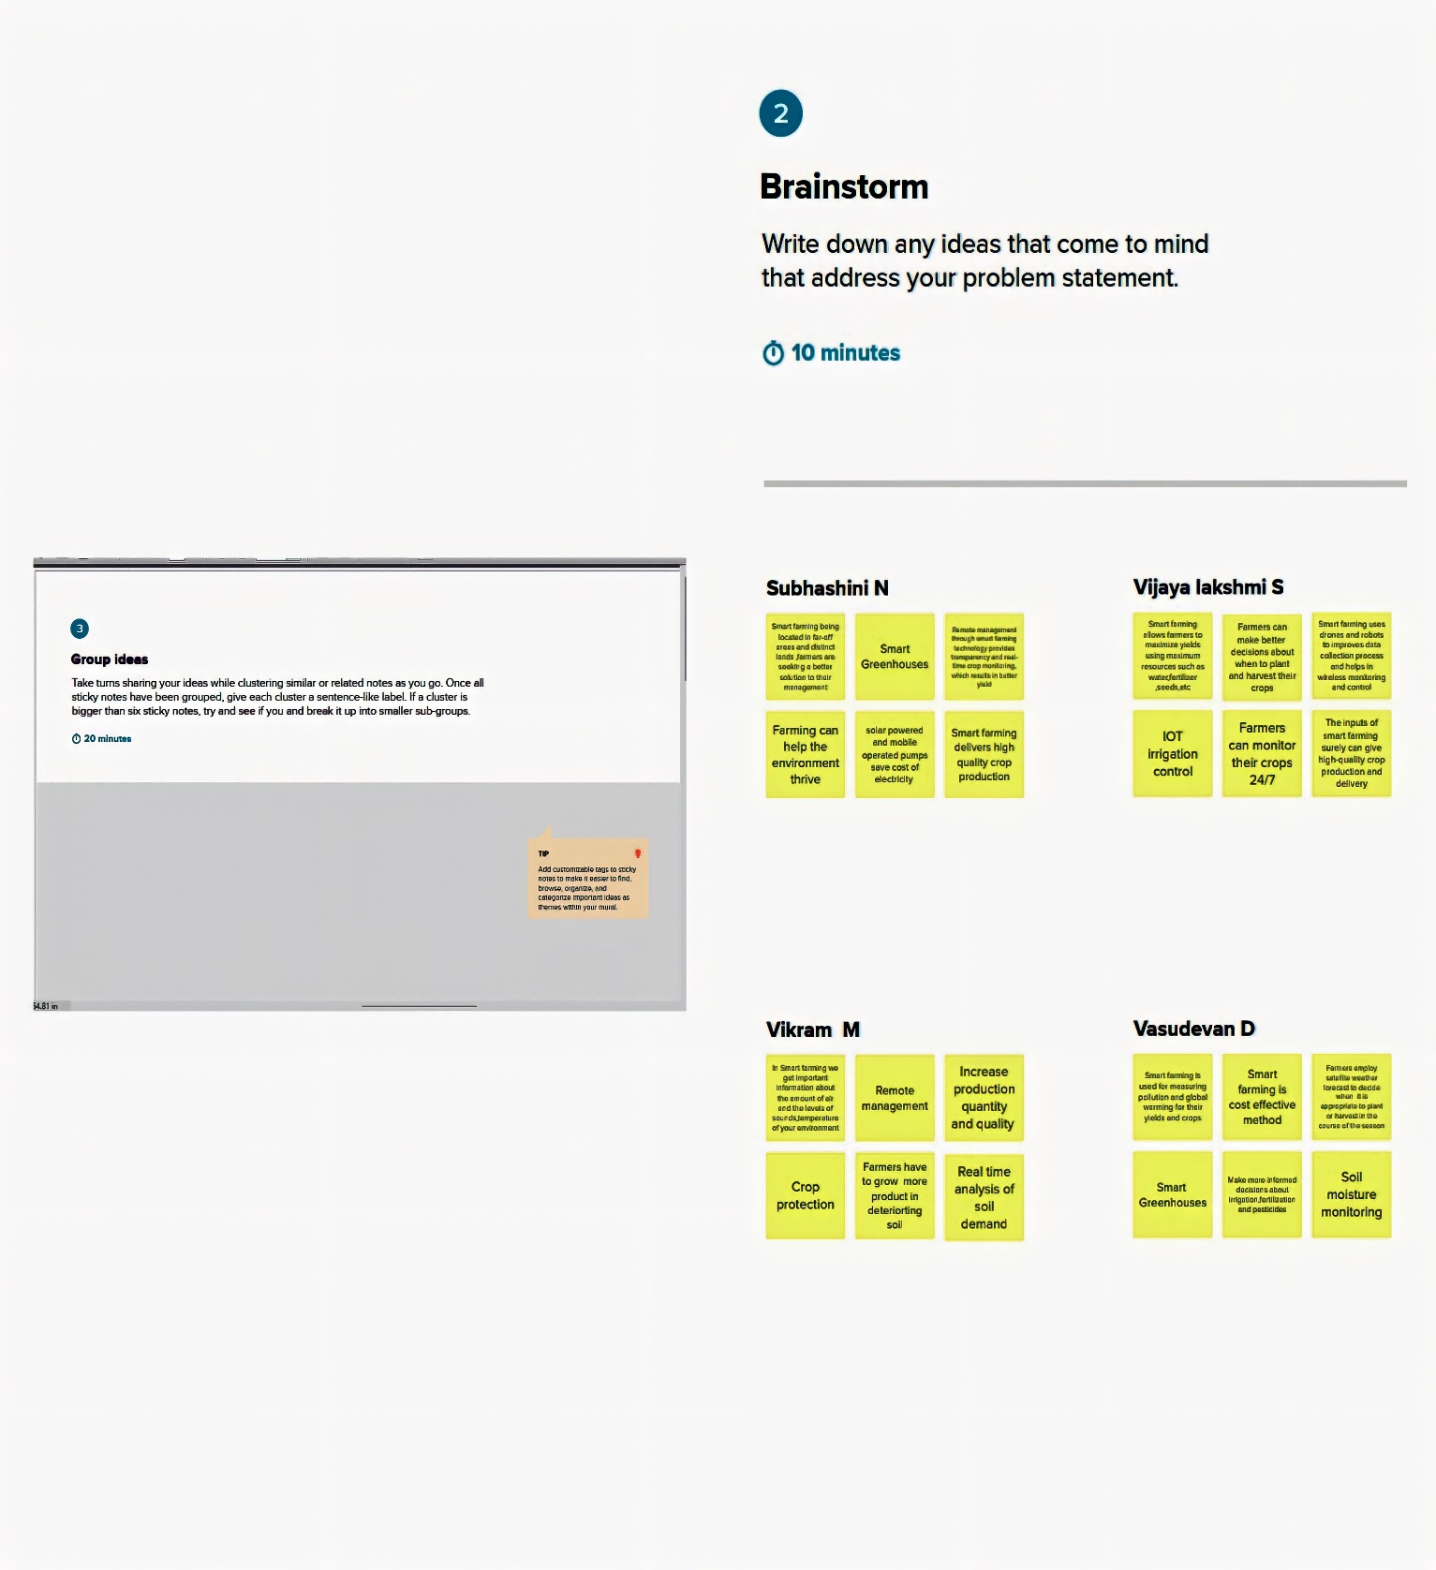

**Step 3: Idea Prioritization**

